Memorial Day Hash Houston Hash
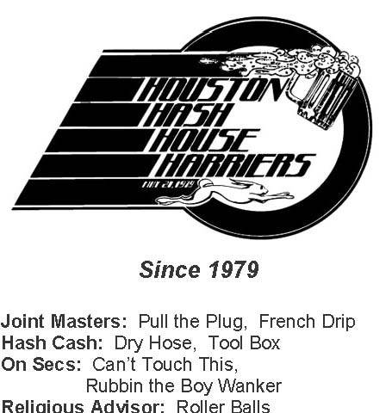

House Harriers
Website: www.h4.org
Hotline: 713-425-4274
Hash TRASH
Run #1454
May 28, 2006

Hares:
Stuck on the Bone Just Kotni Closet Queen Rubbin the Boy Wanker
"Hashin' my Life Away" or, "Between the Bitches" (I mean, ditches).
First, thanks to our hares, Stuck on the Bone, Rubbin' (the birthday kids), Closet Queen and virgin hare Just Kotni. I love those long straight bayous, so this hound was quite pleased with Sunday's trail. Besides, Stuck risked all by nearly disappearing forever under the muck laying trail... What a harriette.
Our fun started with the ususal joyous coughing up of $5, but to our new Hash Cashers, and seeing yet more new and visiting faces at the start. That's been happening a lot lately. Specifically, I remember Can't Stop Coming (from Austin -we had a small Can't family reunion while pick-up wanking to the beer check), a couple of tattooed virgins, and our gift-bearing visitor from Bangladesh.
Pretty good sized pack -about 55 plus Holden, dogs, hares n' new boots, and 5 or 6 more who showed up at the on-in. Deceptively cloudy cool-looking sky, yet downright greasy humidity. The sweat was rolling before chalk talk, and in the short time the pack took to step it to the beer check, they looked like they had already been swimming. A few hashers were heat dazed, andhad to be told that the trail was gonna take more than 20 minutes ,
i.e. the beer check at Rubbin's was NOT the "end". Heartache apparently missed this altogether, shortcutting the already-less-than-taxing trail. But a few gulps of beer, the promise of a dip later, and a Pretty Short Trot to the (Jello) Shot check kept morale high enough. Our gracious new-boot shot-tenders gave the ultimate compliment, so I'm told... "These people are even crazier than we are!" The skeeters threatened to be a nuisance early on, but subsided by the time we got past the first subdivision. No one complained about the lack of poison ivy, either. Next thing we knew, it was On-in, and full immersion into the lagoon paradise of Stuck's back yard. Barbecued chicken, home-baked desserts, corn and cheese "something" that was worth scraping the pan to investigate, TWO kegs of beer, and free-flowing margaritas so tasty they never had time to freeze... Cock Broker and I tipped the machine to get the last two. Don't know if it was invisible four residue or the visible effects of alcohol that contributed to the only injuries (both post run): Twist and Shout's serious Hash Gash while saying goodbye, and Closet Queen's broken toe, sustained by carrying ice through the mayhem, like Gunga Din, to the keg.
Roller Balls donned the ceremonial RA shroud and turban, and got us off to a raucous start for the year. As usual, somebody or other talked almost constantly, an H4 characteristic we might as well learn to love, or love to hate. If we really curbed it, we'd probably lose something in spontaneity... Just Kotni was fittingly doused in flour, but in a poolside puddle that remained a slimey patch under a couple of towels for the rest of the circle. Lots of lame and lamer accusations, with the real focus on getting back to the party... Please write in if one stands out to you. For my part, I'll do my best to get hold of and post the pix from the security camera that Shuttle Cock and Gonad stripped for. Otherwise, check out the email on the H4 site and see Pull the Plug's photos.

Faithfully submitted and ON-ON,
---Can‘t Touch This ---

