Erections - 2006  Hares: Tonka F*ck | Houston Hash House Harriers  Website: www.h4.org  Hotline: 713-425-4274  Hash TRASH  Run #1459  May 20, 2006 | 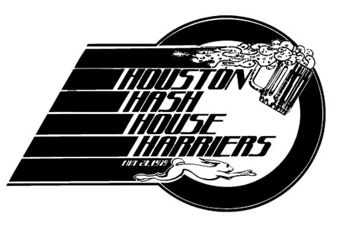  Since 1979  Joint Masters: Pull the Plug, French Drip  Hash Cash: Dry Hose, Tool Box  On Secs: Can’t Touch This,  Rubbin the Boy Wanker  Religious Advisor: Roller Balls

Random thoughts and musings while on trail. While driving to the hash I ponder, “Is it wrong to want to be on mismanagement or to have accepted the nomination.” But then I through in some techno music, “Take California” by the Properllerheads and wonder if I can write music like that. So I arrive at the hash in plenty of time to pander for votes. I see some virgins, some reboots, and a few people that I saw no less than 24 hours ago at the Galveston hash. About 75 people I would imagine give or take 25.
We get the chalk talk from Tonka. It’s a typical trail with urban shiggy (cool – perfect for today, as it’s all about the circle). “Trail starts that way!”
I head off around the building thinking that’s where I’d lay trail. I hear on-ons to right and begin to head that way and realize I’ve shortcut that part of trail. Yes. Trail comes to a check and we see Gonad in the distance looking in the ditch. So we find no trail, but I run along the ditch not seeing trail, but shortcutting and paralleling the pack along with Salt Water Taffy and John Boy. John Boy finds trail on the other side of the freeway and so we run and run and walk and run. There’s one check in the neighborhood which confused the pack, but eventually it’s solved.
I see many hashers walking due to the heat, so I take a breather along with Brrrrrrrrgh and Sticky Lips. We get some help from some of the locals and so I begin to run along having rested up. Will He Peter is running along side me and we begin to discuss the predilections of conservative women vs. liberal women. We come to the same conclusion, hard for a liberal and conservative to agree, but we do. Trail ends behind St. Arnolds.

Okay the moment current mismanagement has wanted to happen for 364 days. Time for new mismanagement:
Joint Masters: Pull the Plug, French Drip
Hash Cash: Dry Hose, Tool Box
On Sec: Can’t Touch This, Rubbin the Boy Wanker
Religious Advisor: Roller Balls
There were a couple new boots: Yvonne from Scotland, Jim (Spot on the Mat’s brother-in-law), Kotni (Stuck on the Bone’s sister), and two other people I forgot there name at this moment. Circle ensued – lots of good accusations, the keg ran dry, more beer was had. Then the party got started at St. Arnolds.
Mismanagement graciously planned a prime ending location – walking distance to the on-on-on, St. Arnolds Brewery. So we proceeded to drink merrily for not just two, but three hours. There was a lively 3man game going thanks to FireTunnel (bringer of 3man).
My last memories of the night were of sucking down margaritas at Tia Maria and closing down the restaurant.
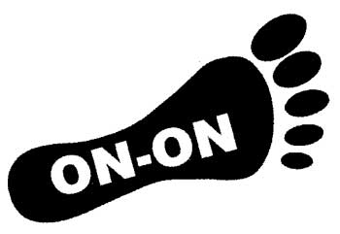

Faithfully submitted and ON-ON,

French Drip

